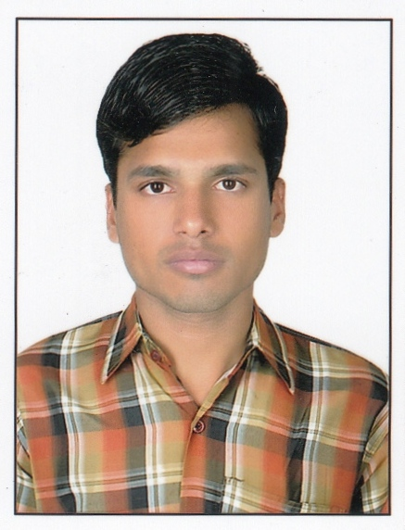
JECRC
JAIPUR

INDIVIDUAL FACULTY DATA SHEET
Name of the faculty member | : | Pradeep Kumar Jain
Present Designation | : | ASSISTANT PROFESSOR
Email Id: pradeepkumar.ce@jecrc.ac.in, pradeepkumar.jain7@gmail.com
Contact Details: 7737707991, 7976187520

I. Particulars of Educational Qualification: (only completed)

Category | Name of the Degree | Specialization | Year of Passing | Name of the College | Name of the University
UG | B.Tech | Civil Engineering | 2013 | JECRC Jaipur | RTU, Kota
PG
Ph.D.

II. Academic Experience : 4 Years and 10 Months

III. Industrial Experience : Nil

IV. Title of Ph.D. Thesis : Nil

V. Awards/Achievements : Nil

VI. Research/Specialization : Nil

VII. Course Taught : Water Recourses Engineering I (7CE1A) & II (8CE1A)

VIII. Refereed International Journal Publication : Nil

IX. International Conference Proceeding : Nil

X. Books Written : Nil

XI. M.Tech Thesis Guide : Nil

XII. PHD Thesis Guide : Nil

XIII. Professional Body Membership : Nil

